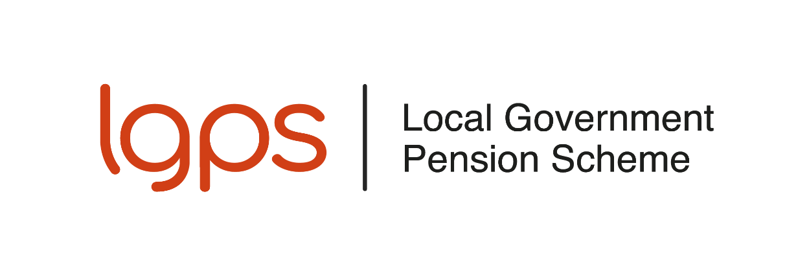
Pensions for Councillors in Wales
The Local Government Pension Scheme (L G P S) is available to all councillors of a Welsh county council or county borough council who are offered membership of the Scheme under their council’s scheme of allowances and who are under age 75.
This leaflet gives you a simple outline of the Scheme. It explains what you will pay in and what benefits you will receive.
The L G P S is a secure and safe scheme. The regulations guarantee your benefits, so you don’t need to worry about stock market performance or changes in share prices. When you retire, the benefits you get are based on the number of years you have been a member of the Scheme and your average pay as a councillor.

How do I join the L G P S?
You can choose to join the Scheme if you are under 75. To secure your entitlement to the Scheme benefits it is important that you complete and return a joining form. Once we receive your form, we will set up your pension record and send you an official notification of your membership of the Scheme.

Can I join if I already pay into another pension?
Yes - you can pay into the LGPS even if you already contribute to another pension scheme. You are allowed to pay into as many pension schemes as you like. In each tax year, you can pay up to 100% of your UK taxable earnings into any number of pension arrangements of your choice and still be eligible for tax relief. If your earnings are lower, you can still pay up to £3,600 into a pension that uses ‘tax relief at source’, such as a personal pension or stakeholder pension scheme.

What do I pay?
As a councillor, you pay 6% of your basic and responsibility allowances into the L G P S – these are your pensionable allowances. You do not pay contributions on:
- any dependants’ carers allowance,
- travelling and subsistence allowance, or
- co-optee’s allowance.
If you pay tax, you will get tax relief on your pension contributions. This means your contributions are taken from your earnings before tax is calculated, reducing the amount of tax you pay.
There is a limit to how much tax relief you can get on pension contributions. If the value of your pension savings grows by more than the annual allowance in a single year, you might have to pay a tax charge. Most people will not be affected by the annual allowance.
Your council pays the rest of the cost of providing your L G P S benefits. On average, the council pays about twice as much as you pay.

What are the benefits?
Life cover from the moment you join, with a lump sum of two times your career average pay paid if you die in service under age 75.
Cover for your family with a pension for your spouse or civil partner and for eligible children should you die.
Retirement benefits after three months’ membership:
You can retire from office and take your pension from age 55, even though the Scheme’s normal pension age is 65. Benefits paid before age 65 will normally be paid at a reduced rate.
The Government has announced that the earliest age you can take your pension will increase to age 57 from April 2028. The LGPS regulations have not yet been amended to reflect this change.
Immediate benefits are payable at any age if you have to retire because of permanent ill health.
When you retire you can look forward to:
- a tax-free lump sum, and
- a pension payable for life that increases each year in line with the appropriate cost of living index.

How are benefits worked out?
When you retire, your LGPS pension is based on your career average pay and how long you have been a member of the Scheme. Each year you are in the Scheme, you build up a pension worth 1/80th of your career average pay.
Annual pension = Membership of the L G P S ÷ 80 × Career average pay
Plus you get a lump sum of three times that amount:
Lump sum = 3 × Annual pension
If you wish, you can give up part of your annual pension to get a larger lump sum when you take your benefits. You can take up to 25% of the capital value of your pension benefits as a lump sum. For every £1 of annual pension you give up, you will receive £12 as a lump sum.
The lump sum is usually paid tax-free but there’s a limit. The maximum tax-free lump sum you can take from all your UK pensions is £268,275. This is known as the lump sum allowance. If you have already taken a pension, you may have used up part of this allowance. A higher limit may apply if you hold lifetime allowance protection.

What is career average pay?
Your career average pay is the average of your councillor allowances over the time you’ve been in the Scheme. It’s worked out like this:
- each year (ending 31 March) your allowances as a councillor are recorded
- except for your final year, each year’s pay is adjusted for inflation using the appropriate index
- all the adjusted yearly amounts are added together and then divided by the number of years (and part years) you’ve been in the Scheme.

Can I transfer previous pension rights into the L G P S?
You cannot transfer previous pension rights into the L G P S from another pension scheme, personal pension plan, another L G P S administering authority or from L G P S membership as an employee. However, if you were previously a councillor in the same LGPS administering authority, you can combine your past LGPS councillor membership with your current one. You must do this within 12 months of rejoining the Scheme, unless your council allows more time.

What happens if I leave before retiring?
If you leave the LGPS before you retire and have at least three months’ membership, your pension benefits will be deferred. This means they’ll be held for you and normally paid from age 65.
You may be able to transfer your L G P S benefits to another pension scheme. You cannot transfer them to another L G P S administering authority in Wales or to any L G P S membership you build up as an employee in England or Wales.
If you leave with less than three months’ membership you may be able to claim a return of your contributions, less tax.

Can I pay more to improve my pension benefits?
You can increase your benefits by making additional voluntary contributions (A V Cs).
You can also choose to pay into a personal pension plan or stakeholder pension scheme alongside your LGPS membership.

How do I join the L G P S?
If you are under age 75 and you wish to join the L G P S:
Administering authorities to insert their own information about joining / forms.
If you opt to join the Scheme, you should check your payslip to make sure pension contributions are being collected from your allowances.

Want to know more?
This leaflet gives a brief outline of the L G P S. You can find more information on the councillor pensions page of the L G P S member website, where you can view a copy of the full Scheme guide.

Disclaimer
This leaflet is for councillors in Wales and reflects the provisions of the L G P S and overriding legislation at the time of publication. The Government may make changes to overriding legislation and, after consultation with interested parties, may make changes in the future to the L G P S.
This leaflet cannot cover every personal circumstance. In the event of any dispute over your pension benefits, the appropriate legislation will prevail. This leaflet does not confer any contractual or statutory rights and is provided for information purposes only.

