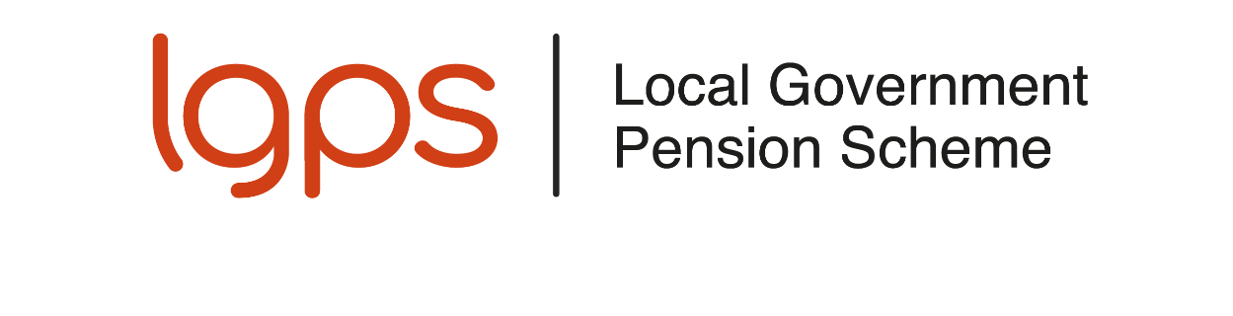Pensions for Councillors in Wales
The Local Government Pension Scheme (L G P S) is available to all councillors of a Welsh county council or county borough council who are offered membership of the Scheme under their council’s scheme of allowances and who are under age 75.
This leaflet gives you a brief outline of the main benefits of the Scheme and explains what you pay in and what you can expect in return.
The L G P S is a secure scheme because the benefits are guaranteed by law. The benefits you get when you retire are based on the number of years you have been a member of the Scheme and your average pay as a councillor. Your benefits are not dependent on share prices and are not affected by stock market fluctuations.

How do I join the L G P S?
It will be up to you to decide whether to join the Scheme, although you have to be under age 75. To secure your entitlement to the Scheme benefits it is important that you complete and return a joining form. On receipt of your form, a relevant pension record will be set up and an official notification of your membership of the Scheme will be sent to you.

Can I join if I already pay into another pension?
Yes - you can pay into as many different pension schemes as you want. You can pay up to 100% of your UK taxable earnings in any one tax year into any number of pension arrangements of your choice (or, if greater, £3,600 to a ‘tax relief at source’ arrangement, such as a personal pension or stakeholder pension scheme) and be eligible for tax relief.

What do I pay?
You currently pay 6% of your basic and responsibility allowances as a councillor into the L G P S. You do not pay contributions on any dependants’ carers allowance, travelling and subsistence allowance or co-optee’s allowance. If you pay tax, you will get tax relief on your contributions when they are deducted from your allowances.
There are restrictions on the amount of tax relief available on pension contributions. If the value of your pension savings increases in any one year by more than the annual allowance you may have to pay a tax charge. Most people will not be affected by the annual allowance.
Your council pays the rest of the cost of providing your L G P S benefits, which costs the council about double the amount you pay.

What are the benefits?
Life cover from the moment you join, with a lump sum of two times your career average pay being paid if you die in service under the age of 75.
Cover for your family with a pension for your spouse or civil partner and for eligible children should you die.
Retirement benefits after three months’ membership:
You can retire from office and take your pension from age 55, even though the Scheme’s normal pension age is 65. Benefits paid before age 65 will normally be paid at a reduced rate.
The Government has announced that the earliest age you can take your pension will increase to age 57 from April 2028. The LGPS regulations have not yet been amended to reflect this change.
Immediate benefits are payable at any age if you have to retire because of permanent ill health.
When you retire you can look forward to:
- a tax-free lump sum, and
- a pension payable for life that increases each year in line with the appropriate cost of living index.

How are benefits worked out?
Your L G P S pension when you retire is calculated as 1/80th of your career average pay for each year of membership of the L G P S:

Annual pension = Membership of the L G P S ÷ 80 × Career average pay
Plus you get a lump sum of three times that amount:
Lump sum = 3 × Annual pension
You can, if you wish, give up some of the pension to get a bigger lump sum when you take your benefits. You may take up to 25% of the capital value of your pension benefits as a lump sum. You receive £12 lump sum for each £1 of annual pension given up.

What is career average pay?
Your career average pay is based on:
- your allowances as a councillor for each year or part year ending 31 March
- other than your final year’s pay, these are adjusted by the change in the cost of living, as measured by the appropriate index(es), between the end of the relevant year and the end of the month in which you leave the Scheme
- the aggregate of each year’s revalued pay is then divided by the total number of years and part years you have been a member of the L G P S to arrive at your career average pay. This is used in the calculation of your L G P S benefits.

Can I transfer previous pension rights into the L G P S?
You cannot transfer previous pension rights into the L G P S from another pension scheme, personal pension plan, another L G P S administering authority or from L G P S membership as an employee. If you have L G P S pension rights from a previous period of councillor membership in the same L G P S administering authority you can join them to your current councillor membership. This must be done within 12 months of re-joining the Scheme, or longer if your council allows.

What happens if I leave before retiring?
If you have at least three months’ membership and you leave before becoming entitled to the immediate payment of your benefits, they will be deferred for payment, normally until age 65.
You may be able to transfer your L G P S benefits to another pension scheme. You cannot transfer them to another L G P S administering authority in Wales or join them to any membership of the L G P S you build up as an employee in England or Wales.
If you have less than three months’ membership you may be able to claim a return of contributions, less tax.

Can I pay more to improve my pension benefits?
You can increase your benefits by making additional voluntary contributions (A V Cs).
You can also pay contributions into a personal pension plan or stakeholder pension scheme.

How do I join the L G P S?
If you are under age 75 and you wish to join the L G P S:
Administering authorities to insert their own information about joining / forms.
If you opt to join the Scheme, you should check your payslip to make sure pension contributions are being collected from your allowances.

Want to know more?
This leaflet gives a brief outline of the L G P S. You can find more information on the councillor page of the L G P S member website, where you can view a copy of the full Scheme guide.

Disclaimer
This leaflet is for councillors in Wales and reflects the provisions of the L G P S and overriding legislation at the time of publication. The Government may make changes to overriding legislation and, after consultation with interested parties, may make changes in the future to the L G P S.
This leaflet is a brief guide to the L G P S for councillors in Wales and cannot cover every personal circumstance. In the event of any dispute over your pension benefits, the appropriate legislation will prevail. This leaflet does not confer any contractual or statutory rights and is provided for information purposes only.

A civil partnership is a relationship between two people of the same or opposite sex (‘civil partners’) which is formed when they register as civil partners of each other.
This is your basic and special responsibility allowance. It does not include any dependants’ carers allowance, travelling and subsistence allowance or co-optee’s allowance.

